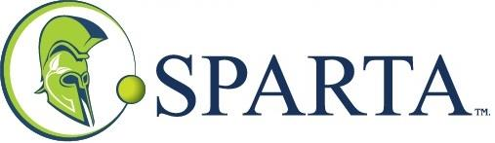
Sparta Capital Ltd. Releases Q1 2020 Financial Results
Not for Distribution to U.S. Newswire Services or for Dissemination in the United States of America. Any Failure to Comply with this Restriction may Constitute a Violation of U.S. Securities laws.
CALGARY, AB / ACCESSWIRE / March 2, 2020 / Sparta Capital Ltd. (TSXV:SAY) (the "Corporation" or "Sparta") announces it has released its financial results for the three months ended December 31, 2019. The Corporation's Q1 financial statements and Management's Discussion & Analysis are available on SEDAR (www.sedar.com) and on the Sparta's website at www.spartacapital.com.
About Sparta
Sparta Capital Ltd. is a company that owns or holds a controlling interest in a network of independent businesses that supply energy saving technologies designed to reduce energy inefficiencies, achieve reduced emissions and increase operating efficiencies in various industries. Sparta's network of independent businesses provide a wide range of specialized energy capturing, converting, optimizing and related services to the commercial sector. Sparta provides capital, technical and engineering expertise, legal support, financial and accounting knowledge, strategic planning and other shared services to its independent businesses.
Sparta is a publicly-traded company listed on the TSX Venture Exchange under the symbol "SAY". Additional information is available on our website at www.spartacapital.com or on SEDAR at www.sedar.com.
For further information please contact:
John O'Bireck, President
Email: jobireck@spartacapital.com
Telephone: (905) 751-8004
Neither TSX Venture Exchange nor its Regulation Services Provider (as that term is defined in the policies of the TSX Venture Exchange) accepts responsibility for the adequacy or accuracy of this release.

AccessWire – Sparta Group

