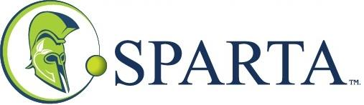

Sparta Group Releases Q3 2020 Financial Results
CALGARY, AB / ACCESSWIRE / August 31, 2020 / Sparta Group (TSXV:SAY) (the "Corporation" the "Company", "Sparta Group", "Sparta Capital" or "Sparta") announces it has released its financial results for the nine months ended June 30, 2020. The Corporation's Q3 financial statements and Management's Discussion & Analysis are available on SEDAR (www.sedar.com) and on the Sparta's website at www.spartagroup.ca.
About Sparta
Sparta Group (a.k.a. Sparta Capital Ltd.) is a technology-based company that owns or holds a controlling interest in a network of independent businesses that supply energy saving technologies designed to reduce energy inefficiencies, achieve reduced emissions and increase operating efficiencies in various industries. In response to the COVID-19 crisis, Sparta has also expanded its scope to help facilitate supply of necessary materials while assisting talented inventors who are looking to introduce innovative technical solutions that will bring greater normalcy to the post COVID-19 world. Sparta's network of independent businesses provides a wide range of specialized energy capturing, converting, optimizing, and related services to the commercial sector. Sparta provides capital, technical and engineering expertise, legal support, financial and accounting knowledge, strategic planning and other shared services to its independent businesses.
Sparta is a publicly-traded company listed on the TSX Venture Exchange under the symbol "SAY". Additional information is available on our website at www.spartagroup.ca or on SEDAR at www.sedar.com.
For further information please contact:
John O'Bireck, President & CTO
Email: jobireck@spartagroup.ca
Telephone: (905) 751-8004
Neither TSX Venture Exchange nor its Regulation Services Provider (as that term is defined in the policies of the TSX Venture Exchange) accepts responsibility for the adequacy or accuracy of this release.

AccessWire – Sparta Group

